Project data & Python 2023

**DOUBLIER Enzo KHOLEEFA Hanna HELLEGOUARCH Bérén**

Final report: The readmission of diabetic patients

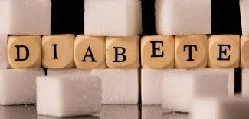

Summary

I -